Phase 3

9 classes

Day 7 : June 11 2024

Spring MVC with database connectivity using JPA

Spring boot With MVC application Database MySQL using

Spring Jpa Data.

Starter -🡪 Web Starter : which provide @Controller, @Service, @Repository etc

Dependencies -🡪 MySQL

Starter -🡪 Jpa Stater : which spring Jpa data features.

Stater 🡪Thymeleaf (it is dynamic html servers side scripting language) like html but dynamic

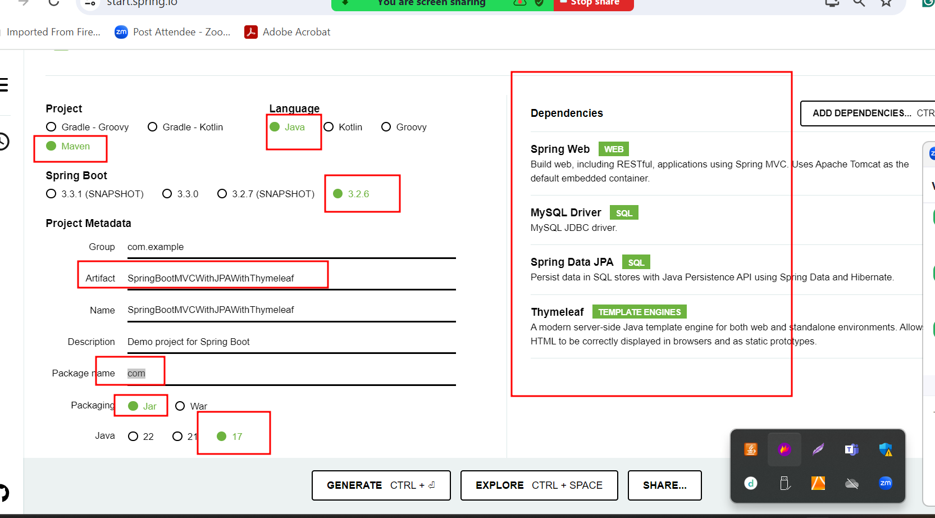

To connect database

1. Core JDBC
2. Spring with JDBC
3. Spring with JdbcTemplate
4. ORM ie JPA
5. Spring jpa data

Spring JPA data is base upon jpa. In Core JPA we need to EntityManagerFactory, EntityManager, EntityTransaction etc.

But in Spring JPA Data they provided few interface which is base upon java 8.(From java 8 onward interface can contains method with body).

1. CrudRepository : Generic repository
2. JpaRepository :JPA specific repository

These interface provided standard dao related method which help to insert, delete, update and retrieve records without writing single line code.

In Spring JPA Data we need to create normal interface and that interface extends CrudRepository or JpaRepository and use pre defined method in service layer to interact with database.

Web Service : Giving the service for web application when both application running using different technologies.

Amazon --🡪 develop using java technologies

Payment

Paypal --🡪Java using spring boot

Paytm 🡪 php

Gpay 🡪asp.net

Credit card 🡪python

Net banking

etc

SOAP base Web Service : Simple object access protocol : in SOAP web service we can consume and product the data only in the form xml. Based base upon SOA (service oriented architecture)

SOAP structure

Restful web service : In Representation State Transfer. Using rest api we can consume as well as produce data in any format base upon client requirement. Like xml, json, plain text, html or any other format.

If our controller is normal controller using @Controller annotation or servlet control then view must be html or jsp or thymeleaf etc.

If our controller is rest controller using @RestController annotation then we can be any other technologies. Like angular, react js, python, php, asp.net or any technologies or any rest client.

Creating more than one rest api

Only one starter ie web starter

